# Technical Specifications

|  |  |  |  |  |  |
| --- | --- | --- | --- | --- | --- |
| Feature | Specified | Current | Improvement out of scope | Comments | Updated |
| WS2812 Interface | Running on the MCU, neither Library or DMA/Peripheral specified | On MCU, 1 PWM/DMA Stream over one GPIO |  |  |  |
| WS2812 Channels | 4 | 1 |  | 9 in total, some axis have 2 LED Rings |  |
| LED-Ring Animations | Not yet (quantity) | 2  Rainbow-like  Solid Color |  | The solid color is hard coded. |  |
|  |  |  |  |  |  |
| 1-Wire Master | Over 1 pin, running on the MCU (no external IC) | Direct communication over 1 pin, NO MASTER |  | GPIO + Timer without slave addressing |  |
| BS18B20 Slave Channels | 10 | 1 only |  | 1 temperature sensor should be on board |  |
| SPI Devices | Master on the MCU | none | LAN9252 working with QUADSPI | EtherCAT and IMU external boards |  |
| SPI Channels | 2 (standard SPI) | none |  |  |  |
| PCB Prototype |  | In process |  |  |  |
| 1 UART Port available | - | none |  | It might be needed for debugging |  |
| Size | As small as possible | 144pin mcu without LAN9252 in first version |  | Use the 64pins version with LAN9252 for second version |  |
| JTAG Connector | Not specified | Included |  |  |  |
|  |  |  |  |  |  |
|  |  |  |  |  |  |
|  |  |  |  |  |  |
|  |  |  |  |  |  |
|  |  |  |  |  |  |
| BISS-C Device* | Running on the MCU | - |  | This is out of scope |  |
| Encoder Channels | 2* | - |  | Pinout should be further investigated |  |

Number of pins





# Timing Specifications

Timing specifications were not given at the beginning; nevertheless, the following data may give a guideline.

RT-Communication for factory automation and motion control according to PROFINET Documentation:

Refresh cycles

Factory automation 5-10 ms

Motion Control 1ms, Jitter <1us

Isochronous transmission of process data (**IRT**)

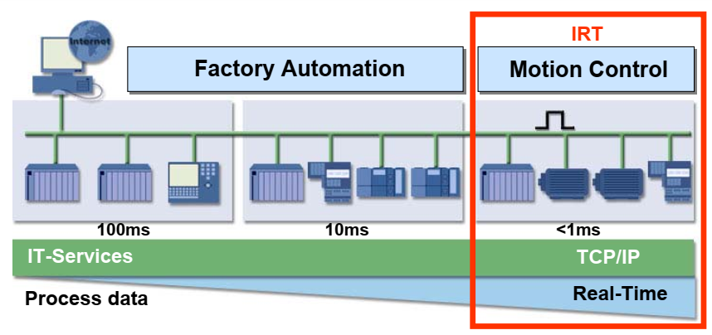

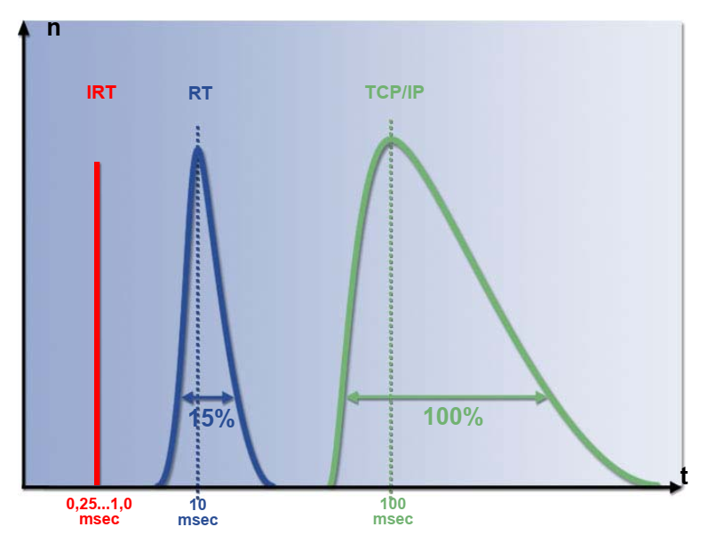

Figure Distribution of refresh times

Jitter

From EtherCAT Master controllers running on IPCs

Telegram System Updates up t0 50 us

Jitter (dynamic compensation) only about 15 us

https://www.ethercat.org/en/products/16A27354739B4B03B7D42D0D9ADBC919.htm

IEEE 1588 describes the clock synchronization in some industrial applications and PROFINET is compatible with it.

## Data to be transferred

The following numbers are just a draft of the amount of data.

|  |  |  |
| --- | --- | --- |
| Temperature data | 10 Chs | Floats (4 Bytes) x 10 = 40 Bytes |
| Biss-C Data | Unknown (out of scope) |  |
| IMU – DATA | Acceleration, Magnetometer, Gyroscope | Floats (4 Bytes) x 3 data x 3 Axis = 36 Bytes |
| Status | General Status, Relevant Events | Unsigned 32 Integers x 2 = 8 |
| Total |  | 84 Bytes 🡪 128 Bytes |

128 Bytes every refreshing cycle of 1 ms leads to 128 KBps = 1024 Kbps

## Hardware constraints

Given the EtherCAT Physical interface that communicates over a SPI capable of 30-40 up to 80 MHz

Configuration as SPI (4 Wires) Full-Duplex, the microcontroller can write to device at 1 bit per CLK cycle, which means the transfer speed can be momentary (40 MHz) equal to 40 Mbps.

|  |  |  |  |
| --- | --- | --- | --- |
| Configuration SPI @ 40 MHz | 40 Mbps (In implementation) | 5 MBps | 5KB per refresh cycle |
| Configuration SPI @ 80 MHz | 80 Mbps (Not yet implemented but theoretically possible) | 10 MBps🡪 | 10KB |
| Configuration SQI @ 80 MHz | 160 Mbps (Theoretically possible with hardware and PCB adjustments) | 20 MBps | 50KB |